**PART IV Answer:**

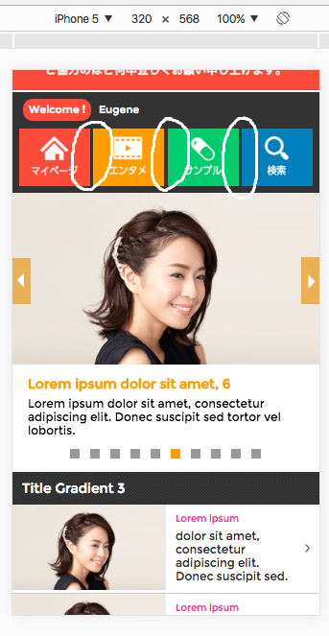Here is additional question you need to answer prior endorsing your profile to our client employer, please see attached images of a web page. Below is their message for the instruction.  
  
***I attached two images of a web page.  
Some parts of these pages have a broken layout.  
Please ask the applicants to list up those parts or parts.  
  
The pages are written in Japanese and it doesn't matter  
because the purpose of this question is to find out whether an applicant   
has attention to detail.***

**Test 1:** The spaces in between those buttons are not equal with each other.

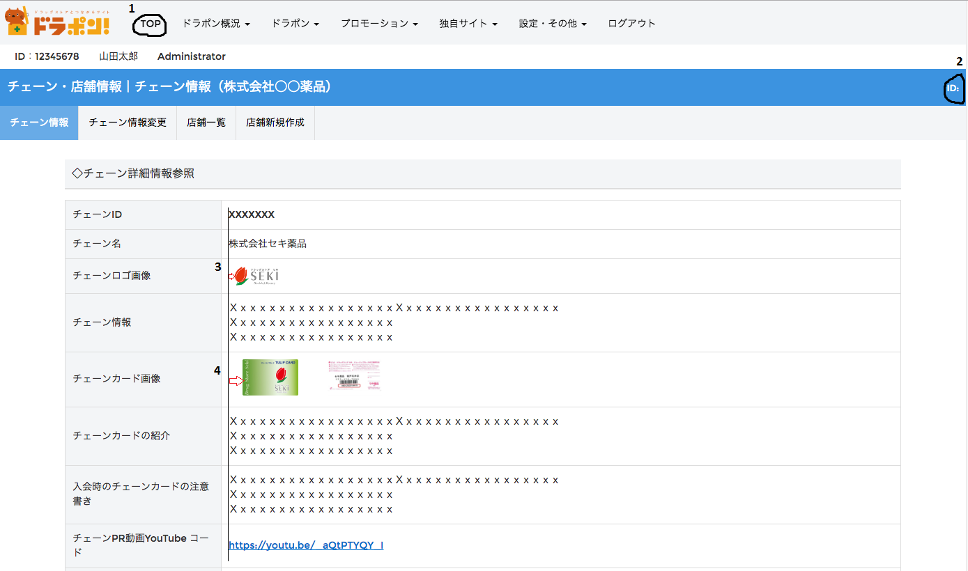

**Test 2:**  
    1. I don't understand why there's a TOP in the navigation bar. I may not understand the writings and all but I think that it should be placed floating in the bottom-left corner of the page.  
    2. The ID: in the right corner of the page should not be in there if there's no value. It should be hidden (I think).  
    3&4. These images are not aligned together with the text contents.  
  
Thanks,